**Logistic Regression Approach to Predict the Success of Bank Telemarketing**

**Student Number:** D20123764

**Name:** Shakti Sampad Dash

**Programme Code:** TU60

**Note:** I have used the direct marketing campaigns of a Portuguese banking institution [dataset](https://archive.ics.uci.edu/ml/datasets/Bank+Marketing) to complete the independent project.

Contents

Abstract 4

Section 1 - Research Question(s) 5

Question-1 5

Section 2 - Dataset 5

How to handle missing data 5

Findings & Actions 6

Representativeness 7

Variables of interest and their statistical measurement type 7

Euribor 3 month rate (uribor3m) 7

Number of employees (nr.employed) 8

Employment variation rate (emp.var.rate) 8

Consumer price index (cons.price.idx) 9

Consumer confidence index (cons.conf.idx) 9

Section 3 - Results 10

Section 3.1 - Statistical Evidence 10

Forward stepwise selection 11

Backward stepwise selection 14

Section 3.2 - Model1| Using predictors from Stepwise forward selection 16

Report 16

Fit and Usefulness of the model 16

Predictors and their significance 17

Assess the model against assumptions 18

Model Equation and Illustration 18

Section 3.3 - Model 2| Using predictors from Stepwise backward selection 20

Report 20

Fit and Usefulness of the model 20

Predictors and their significance 21

Assess the model against assumptions 22

Model Equation and Illustration 22

Section 3.4 |Summary Comparison 23

Differences in fit and usefulness 23

How models meet assumptions 24

Section 4 – Discussion/Conclusion 25

# Abstract

We propose to do a logistic regression approach to understand the attributes which influences the decision for subscribing to a bank long term deposit and predict the success of telemarketing calls for selling bank long term deposit. We are given the data of direct marketing campaigns (phone calls) of a Portuguese banking institution. The classification goal is to predict if the client will subscribe a term deposit (target variable y).

The dataset consists of direct marketing campaigns data of a banking institution. The dataset was picked from UCI Machine Learning Repository which is an amazing source for publicly available datasets. There were four variants of the datasets out of which we chose “bank-additional-full.csv” which consists of 41188 data points with 20 independent variables out of which 10 are numeric features and 10 are categorical features. The data is collected during the period of May 2008 and November 2010. The list of features available to us is given below:

**Bank client data:**

|  |  |  |
| --- | --- | --- |
| **Feature** | **Feature type** | **Description** |
| age | numeric | Age of the customer |
| job | categorical | Type of job (admin, blue-collar, entrepreneur, housemaid, management, retired, self-employed, services, student, technician, unemployed, unknown) |
| marital | categorical | Marital status |
| education | categorical | Education details (basic.4y, basic.6y, basic.9y, high.school, illiterate, professional.course, university.degree, unknown) |
| default | categorical | Has credit in default? (no, yes, unknown) |
| housing | categorical | Has housing loan? (no, yes, unknown) |
| loan | categorical | Has personal loan? (no, yes, unknown) |

**Related with the last contact of the current campaign:**

|  |  |  |
| --- | --- | --- |
| **Feature** | **Feature type** | **Description** |
| contact | categorical | Contact communication type (cellular, telephone) |
| month | categorical | Last contact month of year (jan, feb, mar etc.) |
| day_of_week | categorical | Last contact day of the week (mon, tue, wed, thu, fri) |
| duration | numeric | Last contact duration, in seconds |

**Previous campaign attributes:**

|  |  |  |
| --- | --- | --- |
| **Feature** | **Feature type** | **Description** |
| campaign | numeric | Number of contacts performed during this campaign and for this client |
| pdays | numeric | Number of days that passed by after the client was last contacted from a previous campaign (999 means client was not previously contacted) |
| previous | categorical | Number of contacts performed before this campaign and for this client |
| poutcome | categorical | Outcome of the previous marketing campaign ( failure, nonexistent, success) |

**Social and Economic context attributes:**

|  |  |  |
| --- | --- | --- |
| **Feature** | **Feature type** | **Description** |
| emp.var.rate | numeric | employment variation rate — quarterly indicator |
| cons.price.idx | numeric | consumer price index — monthly indicator |
| cons.conf.idx | numeric | consumer confidence index — monthly indicator |
| euribor3m | numeric | euribor 3 month rate — daily indicator |
| nr.employed | numeric | number of employees — quarterly indicator |

# Section 1 - Research Question(s)

## Question-1

Do the social and economic indicators, client data and previous campaign attributes have an influence on a customer subscribing to a term deposit subscription?

# Section 2 - Dataset

## How to handle missing data

The missing data are present in then below columns and marked as ‘unknown’:

1. job
2. marital
3. education
4. default
5. housing
6. loan

We have replaced the ‘unknown’ with NA and find out the pattern in missing data. Below are the test results:

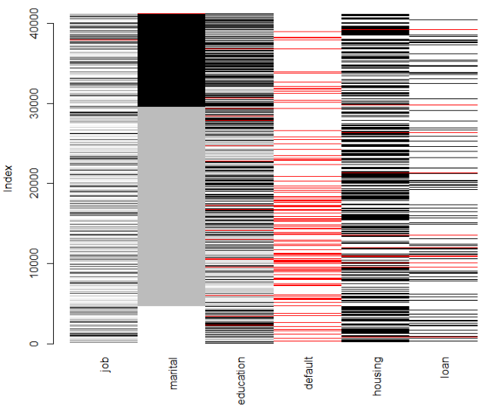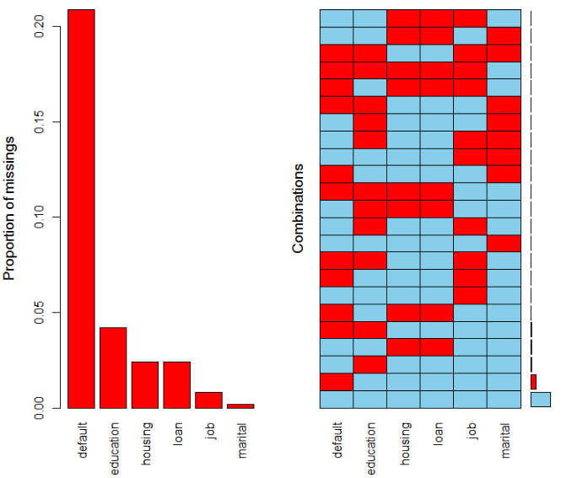

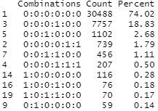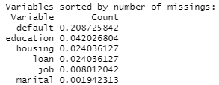

### Findings & Actions

* We can see the most common pattern is where all variables are having data - no missing data (74.02%). The next most common is where ‘default’ alone is missing - 7757 cases. Then when the ‘education’ alone is missing – 1102.
* The ‘default’ column is having a much skewed data and more than 20% value missing. So this variable is dropped/not used in the upcoming models.



* When ‘housing’ is missing the ‘loan’ column is missing and vice versa. There are total 990 such records present in the data. We took the summary of the whole data set when housing and loan is missing and found the missingness is not dependent on any other variable.

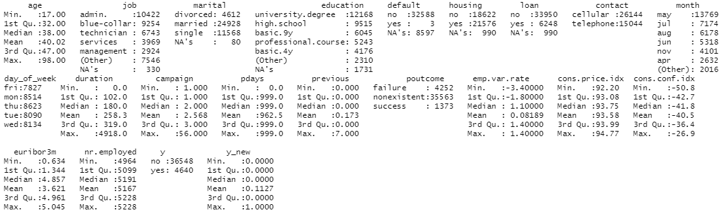

* We will ignore all these missing data as it is missing completely at random and delete them from the dataset.

## Representativeness

The study considers real data collected from a Portuguese retail bank from May 2008 to November 2010. As there was a global recession going on it is quite obvious that most of the people need money in hand and as a result most of the customers did not opt for the term deposit. So, the dataset is unbalanced, after removing the missing data only 3859 (12.65%) records are related to success.

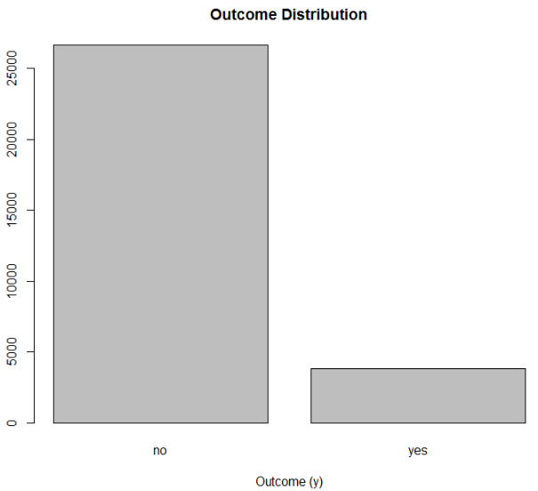

## Variables of interest and their statistical measurement type

### Euribor 3 month rate (uribor3m)

This is a social economic numeric variable. We will check the normality of the variable.

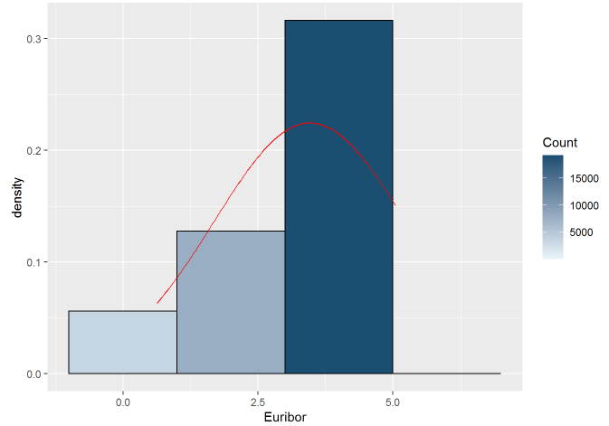 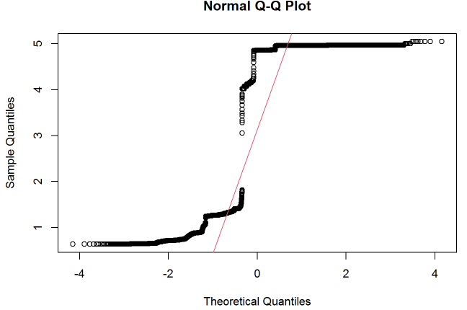

Euribor 3 month rate score data was assessed for normality. Visual inspection of the histogram and QQ-Plot (see Figure 1 and Figure 2) identified some issues with skewness and kurtosis. The standardised score for kurtosis (-58.17) and the standardised score for skewness (-37.43) were outside the acceptable range using the criteria proposed by West, Finch and Curran (1996). However 100% of standardised euribor 3 month rate fall within the bounds of +/- 3.29, using the guidance of Field, Miles and Field (2013) the data can be considered to approximate a normal distribution (m=3.46, sd=1.78, n=30488).

### Number of employees (nr.employed)

This is a social economic numeric variable. We will check the normality of the variable.

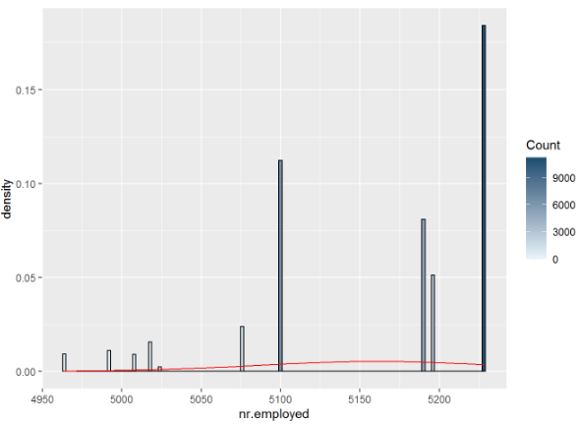 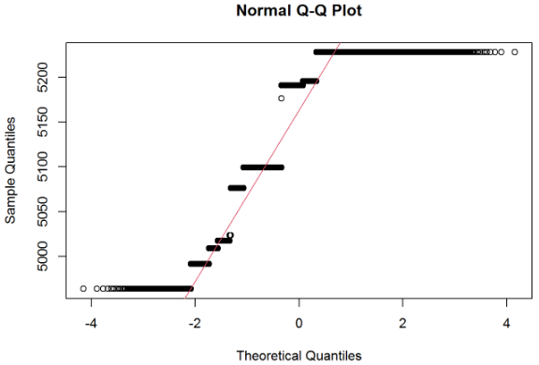

Number of employees data was assessed for normality. Visual inspection of the histogram and QQ-Plot (see Figure 1 and Figure 2) identified some issues with skewness and kurtosis. The standardised score for kurtosis (-12.53) and the standardised score for skewness (-63.71) were outside the acceptable range using the criteria proposed by West, Finch and Curran (1996). However 100% of standardised number of employees fall within the bounds of +/- 3.29, using the guidance of Field, Miles and Field (2013) the data can be considered to approximate a normal distribution (m=5160.81, sd=75.16, n=30488).

### Employment variation rate (emp.var.rate)

This is a social economic numeric variable. We will check the normality of the variable.

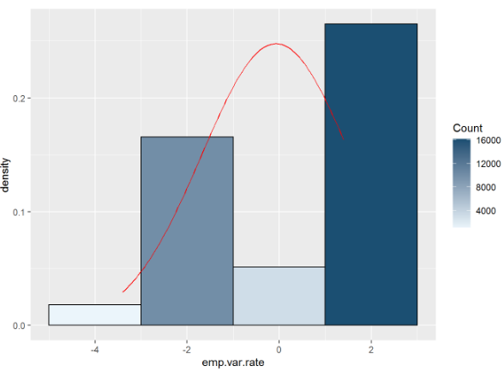 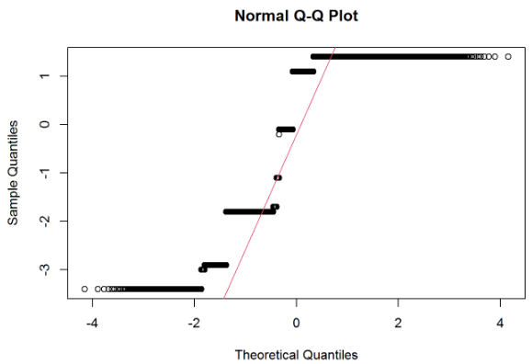

Employment variation rate score data was assessed for normality. Visual inspection of the histogram and QQ-Plot (see Figure 1 and Figure 2) identified some issues with skewness and kurtosis. The standardised score for kurtosis (-45.32) and the standardised score for skewness (-39.13) were outside the acceptable range using the criteria proposed by West, Finch and Curran (1996). However 100% of standardised employment variation rate fall within the bounds of +/- 3.29, using the guidance of Field, Miles and Field (2013) the data can be considered to approximate a normal distribution (m=-0.07, sd=1.61, n=30488).

### Consumer price index (cons.price.idx)

This is a social economic numeric variable. We will check the normality of the variable.

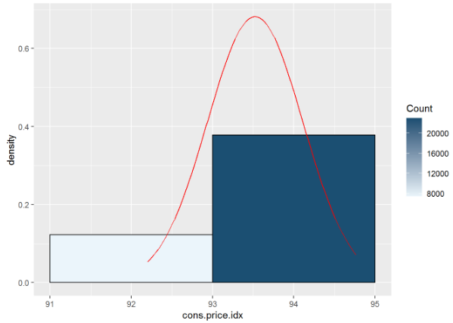 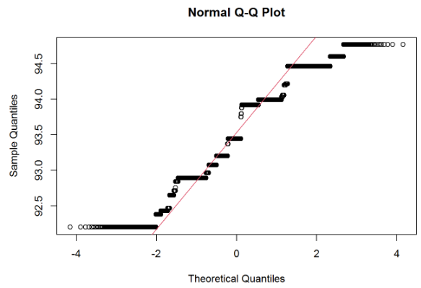

Consumer price index score data was assessed for normality. Visual inspection of the histogram and QQ-Plot (see Figure 1 and Figure 2) identified some issues with skewness and kurtosis. The standardised score for kurtosis (-30.77) and the standardised score for skewness (-8.46) were outside the acceptable range using the criteria proposed by West, Finch and Curran (1996). However 100% of standardised consumer price index fall within the bounds of +/- 3.29, using the guidance of Field, Miles and Field (2013) the data can be considered to approximate a normal distribution (m=93.52, sd=0.59, n=30488).

### Consumer confidence index (cons.conf.idx)

This is a social economic numeric variable. We will check the normality of the variable.

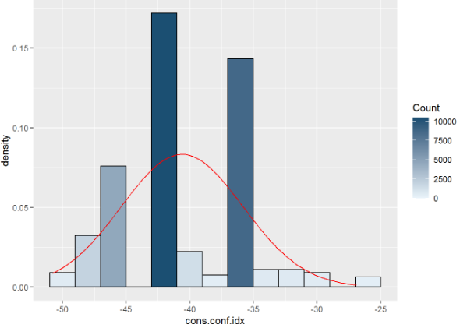 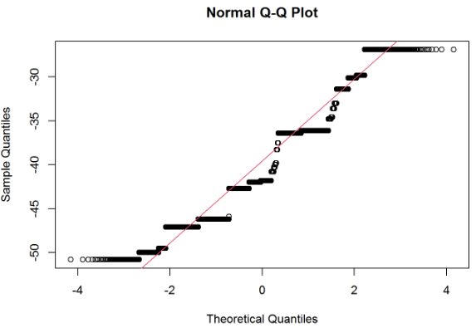

Consumer confidence index score data was assessed for normality. Visual inspection of the histogram and QQ-Plot (see Figure 1 and Figure 2) identified some issues with skewness and kurtosis. The standardised score for kurtosis (-11.53) and the standardised score for skewness (26.66) were outside the acceptable range using the criteria proposed by West, Finch and Curran (1996). However 100% of standardised consumer confidence index fall within the bounds of +/- 3.29, using the guidance of Field, Miles and Field (2013) the data can be considered to approximate a normal distribution (m=-40.6, sd=4.79, n=30488).

# Section 3 - Results

## Section 3.1 - Statistical Evidence

* The last call duration should be removed while creating the models as this data can only be collected once the call is over and by then the outcome is already known. So, to predict the outcome call duration can’t be used.
* As discussed in the missing data analysis section, ‘default’ (Has a credit in default?) column is having a much skewed data and more than 20% value missing. So this variable is dropped/not used in the upcoming models.



* All the social economic attributes are highly correlated as all of them are trying to narrate the current economic situation. As per one of the assumption of the logistic regression, the independent variables should not be too highly correlated to each other. We conducted Pearson correlation test to examine the correlation between the social economic attributes. Pearson’s test is chosen as in the previous section we have already found out the entire social and economic variables are normally distributed.

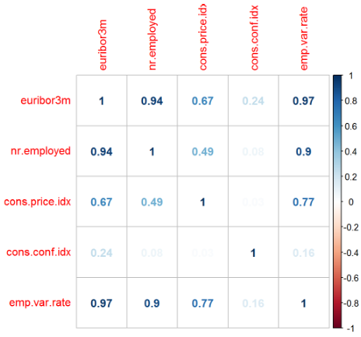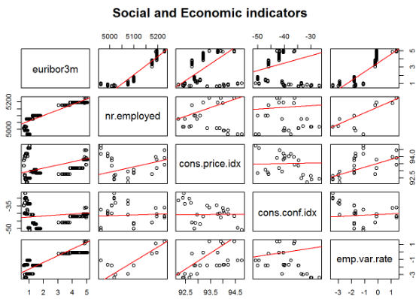

* First we created the correlation matrix for all the social economic attributes and also created the scatter plots. Then correlation tests are performed between the number of employees per quarter and all other social economic attributes.
* The relationship between number of employees per quarter and euribor 3 months rate was investigated using a Pearson correlation. A strong positive correlation was found (r =0.945, n=30486, p<.001).
* The relationship between number of employees per quarter and consumer pricing index monthly rate was investigated using a Pearson correlation. A strong positive correlation was found (r =0.489, n=30486, p<.001).
* The relationship between number of employees per quarter and consumer confidence index monthly rate was investigated using a Pearson correlation. A weak positive correlation was found (r =0.075, n=30486, p<.001).
* The relationship between number of employees per quarter and employment quarterly variation rate was investigated using a Pearson correlation. A strong positive correlation was found (r =0.900, n=30486, p<.001).
* Only number of employees per quarter and consumer confidence index monthly rate social economic attributes will be used for the model creation as they are weakly correlated. All the other social economic attributes are strongly correlated with number of employees per quarter, so those attributes will not be used in model building.
* All the below attributes will be used to create the model:
  1. Number of employees per quarter
  2. Consumer confidence index monthly rate
  3. Age of the customer
  4. Job of the customer
  5. Marital status of the customer
  6. Education of the customer
  7. Housing loan status
  8. Personal Loan status
  9. Customer communication type
  10. Last contact month
  11. Last contact day of the week
  12. Number of contacts performed during this campaign and for this client
  13. Number of days that passed by after the client was last contacted from a previous campaign
  14. Number of contacts performed before this campaign and for this client
  15. Outcome of the previous marketing campaign
* Below two different variable section methods are used two narrow down from the 15 attributes mentioned above to the most statistically significant attributes which will provide the better fit and efficient model.
  1. Stepwise forward selection
  2. Stepwise backward selection

### Forward stepwise selection

In this selection method, we pick one attribute from the above list of 15 variables and create a logistic regression mode. We check the statistical significance of the attribute for the prediction and performance of the model to decide whether the variable is helping the prediction or should be removed from the model. By applying this technique we create below 16 models and compared them by Predictor probability, AIC and AUC and choose the final list of variables and optimum model to predict the outcome variable.

|  |  |  |  |  |  |
| --- | --- | --- | --- | --- | --- |
| **Model #** | **Predictor added** | **Pr(>|z|)** | **AIC** | **AUC** | **Conclusion** |
| 1 | Number of employees per quarter | <0.001 | 19532 | 0.758 | Predictor selected. |
| 2 | Consumer confidence index monthly rate | <0.001 | 19470 | 0.748 | Predictor rejected as AUC dropped. |
| 3 | Age of the customer | <0.05 | 19526 | 0.756 | Predictor rejected as AUC dropped and very small improvement in AIC. |
| 4 | Job of the customer | <0.05 for 50% of categories | 19421 | 0.763 | Predictor selected. Rise in AUC and decrease in AIC. |
| 5 | Marital status of the customer | 0.44 for married  0.12 for single | 19422 | 0.764 | Predictor rejected as Probability >0.05 and increase in AIC. |
| 6 | Education of the customer | 0.59 for basic.6y  0.41 for basic.9y  0.79 for high.school  0.07 for illiterate  0.51 for professional.course  <0.05 for university.degree | 19410 | 0.766 | Predictor rejected as more than 80% of the categories are having Probability >0.05 |
| 7 | Housing loan status | 0.38 | 19422 | 0.763 | Predictor rejected as Probability >0.05 and increase in AIC. |
| 8 | Personal loan status | 0.52 | 19422 | 0.763 | Predictor rejected as Probability >0.05 and increase in AIC. |
| 9 | Customer communication type | <0.001 | 19292 | 0.774 | Predictor selected. Rise in AUC and decrease in AIC. |
| 10 | Last contact month | <0.05 for 77% of categories | 18835 | 0.786 | Predictor selected. Rise in AUC and decrease in AIC. |
| 11 | Last contact day of the week | <0.05 for 75% of category | 18789 | 0.788 | Predictor selected. Rise in AUC and decrease in AIC. |
| 12 | Number of contacts performed during this campaign and for this client | <0.001 | 18767 | 0.789 | Predictor selected. Rise in AUC and decrease in AIC. |
| 13 | Number of days that passed by after the client was last contacted from a previous campaign | <0.001 | 18351 | 0.795 | Predictor selected. Rise in AUC and decrease in AIC. |
| 14 | Number of contacts performed before this campaign and for this client | <0.001 | 18285 | 0.797 | Predictor selected. Rise in AUC and decrease in AIC. |
| 15 (a) | Outcome of the previous marketing campaign | <0.001 | 18258 | 0.797 | Predictor selected. Decrease in AIC. |
| 15 (b) | Number of contacts performed before this campaign and for this client | 0.205 | 18258 | 0.797 | Predictor rejected as Probability >0.05 |
| 16 | Removed: Number of contacts performed before this campaign and for this client | NA | 18258 | 0.797 | Predictor removed as per the conclusion drawn from 15 (b). AIC and AUC remain unchanged. |

Following are the list of attributes which are selected in the forward stepwise selection:

1. Number of employees per quarter
2. Job of the customer
3. Customer communication type
4. Last contact month
5. Last contact day of the week
6. Number of contacts performed during this campaign and for this client
7. Number of days that passed by after the client was last contacted from a previous campaign
8. Outcome of the previous marketing campaign

We created a model with above attributes. Examination for multicollinearity showed that the tolerance and variance influence factor measures for ‘Number of days that passed by after the client was last contacted from a previous campaign’ (pdays) predictor were not within acceptable levels (tolerance >0.4, VIF <2.5 ) as outlined in Tarling (2008). So, ‘Number of days that passed by after the client was last contacted from a previous campaign’ (pdays) is removed from the final model.

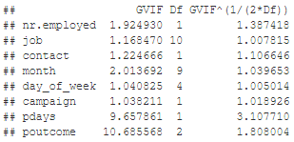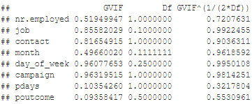

### Backward stepwise selection

In this selection method, we pick all 15 attributes and create a logistic regression mode. We remove all the attributes which are statistically not significant in the model (Probability >0.05). By applying this technique we create below 2 models and compared them by Predictor probability, AIC and AUC and choose the final list of variables and optimum model to predict the outcome variable.

|  |  |  |  |  |  |
| --- | --- | --- | --- | --- | --- |
| **Model #** | **Predictors with Pr(>|z|) >0.05** | **Pr(>|z|)** | **AIC** | **AUC** | **Conclusion** |
| 1 | Age of the customer | 0.869 | 18256 | 0.797 | Predictor rejected as Probability >0.05 |
| Job of the customer | blue-collar <0.05  entrepreneur 0.45  housemaid 0.92  management 0.60  retired <0.05  self-employed 0.73  services 0.06  student <0.05  technician 0.78  unemployed 0.82 | Predictor rejected as Probability >0.05 for 70% categories. |
| Marital status of the customer | Married 0.62  Single 0.54 | Predictor rejected as Probability >0.05 |
| Education of the customer | basic.6y 0.28  basic.9y 0.84  high.school 0.33  illiterate 0.11  professional.course 0.43  university.degree 0.08 | Predictor rejected as Probability >0.05 |
| Housing loan status | 0.26 | Predictor rejected as Probability >0.05 |
| Personal loan status | 0.66 | Predictor rejected as Probability >0.05 |
| Number of contacts performed before this campaign and for this client | 0.33 | Predictor rejected as Probability >0.05 |
| 2 | All attributes except the once rejected in the above model | <0.05 | 18260 | 0.796 | Predictors selected as probability <0.05 and very small change in AIC and AUC. |

Following are the list of attributes which are selected in the backward stepwise selection:

1. Number of employees per quarter
2. Consumer confidence index monthly rate
3. Customer communication type
4. Last contact month
5. Last contact day of the week
6. Number of contacts performed during this campaign and for this client
7. Number of days that passed by after the client was last contacted from a previous campaign
8. Outcome of the previous marketing campaign

We created a model with above attributes. Examination for multicollinearity showed that the tolerance and variance influence factor measures for ‘Number of days that passed by after the client was last contacted from a previous campaign’ (pdays) predictor were not within acceptable levels (tolerance >0.4, VIF <2.5 ) as outlined in Tarling (2008). So, ‘Number of days that passed by after the client was last contacted from a previous campaign’ (pdays) is removed from the final model.

## Section 3.2 - Model1| Using predictors from Stepwise forward selection

### Report

A binomial logistic regression analysis was conducted to know the outcome of a bank telemarketing campaign using Number of employees per quarter, Job of the customer, Customer communication type, Last contact month, Last contact day of the week, Number of contacts performed during this campaign and for this client and Outcome of the previous marketing campaign as predictors.

The data met the assumption for independent observations. Examination for multicollinearity showed that the tolerance and variance influence factor measures were within acceptable levels (tolerance >0.4, VIF <2.5) as outlined in Tarling (2008). The Hosmer Lemeshow goodness of fit statistic did not indicate any issues with the assumption of linearity between the independent variables and the log odds of the model (χ2(n=8)= =48.538, p <0.001).

### Fit and Usefulness of the model

* The AIC is the measure of fit which penalizes model for the number of model coefficients. Therefore, we always prefer model with minimum AIC value. For this model the AIC value is 18282.
* Receiver Operating Characteristic (ROC) summarizes the model’s performance by evaluating the trade-offs between true positive rate (sensitivity) and false positive rate (1- specificity). The area under curve (AUC), referred to as index of accuracy. Higher the area under curve, better the prediction power of the model. Below is a ROC curve for the model:

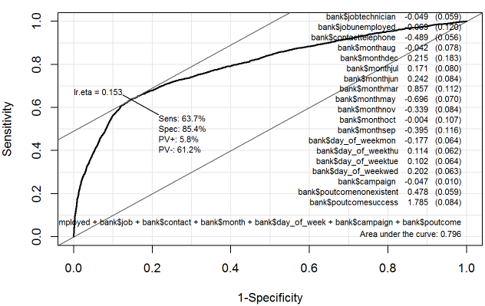

* Confusion metrics of the model:

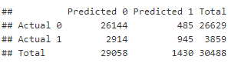

* The model is significant Chi sq= 4962.4, p<0.01. We have calculated the pseudo R Square statistics using Cox and Snell and Nagelkerke formula. The pseudo R square indicate that between 15.02% and 28.22% of the variability of responses to whether the customer opts for the term deposit or not.

### Predictors and their significance

* The model is created using 7 predictors mentioned below:
  1. Number of employees per quarter
  2. Customer Job
  3. Customer communication type
  4. Last contact month
  5. Last contact day of the week
  6. Number of contacts performed during this campaign and for this client
  7. Outcome of the previous marketing campaign
* Following are the co-efficient of the predictors along with their statistical significance:

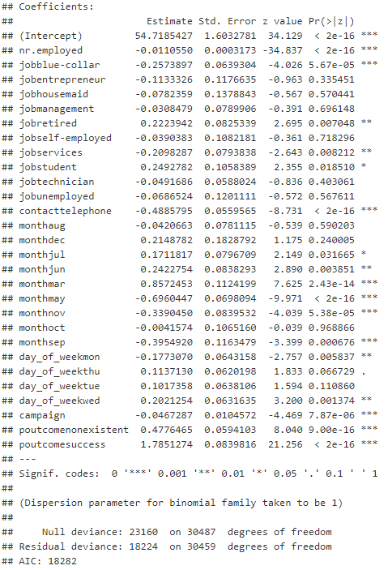

* Following are the odds ratio of all the predictors:

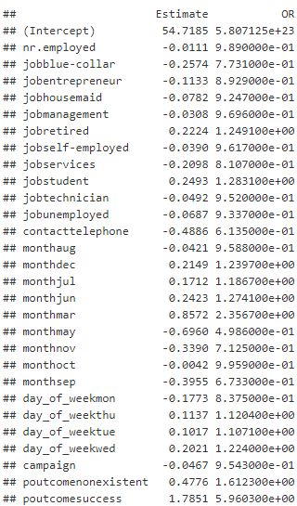

### Assess the model against assumptions

* The outcome variable can be ‘Yes’ or ‘no which means it is categorical and binomial in nature.
* The observations are individual calls made to different customers over period of time which means each observations are independent to one another.
* Examination for multicollinearity showed that the tolerance and variance influence factor measures were within acceptable levels (tolerance >0.4, VIF <2.5) as outlined in Tarling (2008).

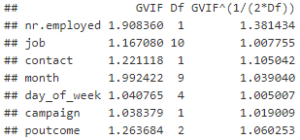 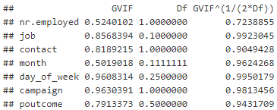

* The Hosmer Lemeshow goodness of fit statistic did not indicate any issues with the assumption of linearity between the independent variables and the log odds of the model (χ2(n=8)= =48.538, p <0.001).

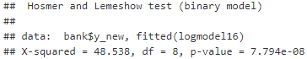

### Model Equation and Illustration

* The logistic regression equation is as follows:



* Where b0,b1b2…bn are the co-efficient. In this model, we found below coefficients

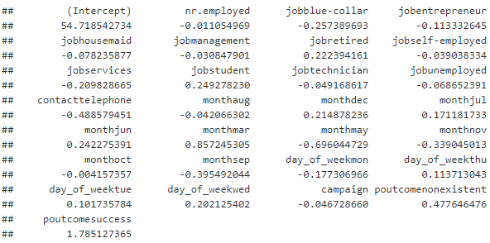

* The equation to calculate the probability for the below query will be:

Probability of bank term deposit sold when number of employees is at its minimum i.e 4963.6, customer has a admin job contacted over cellular phone in the month of march, Wednesday, contacted once during this campaign and had a successful prior campaign.

54.71+(-0.011)* 4963.6+0.857*1+0.202*1+(-0.047)*1+1.785*1

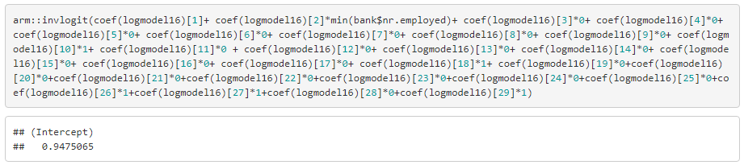

The probability is 94% of bank term deposit sold when number of employees is at its minimum i.e 4963.6, customer has a admin job contacted over cellular phone in the month of march, Wednesday, contacted once during this campaign and had a successful prior campaign.

* Probability of bank term deposit sold when number of employees is at its minimum i.e. 4963.6, customer is a student contacted over telephone in the month of May, Monday, contacted once during this campaign and had a failure prior campaign

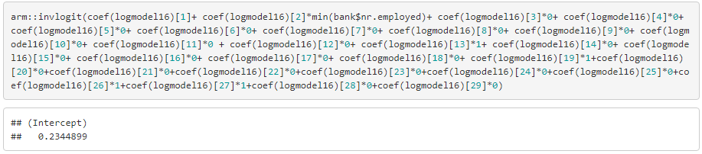

## Section 3.3 - Model 2| Using predictors from Stepwise backward selection

### Report

A binomial logistic regression analysis was conducted to know the outcome of a bank telemarketing campaign using Number of employees per quarter, Consumer confidence index monthly rate, Customer communication type, Last contact month, Last contact day of the week, Number of contacts performed during this campaign and for this client and Outcome of the previous marketing campaign as predictors.

The data met the assumption for independent observations. Examination for multicollinearity showed that the tolerance and variance influence factor measures were within acceptable levels (tolerance >0.4, VIF <2.5) as outlined in Tarling (2008). The Hosmer Lemeshow goodness of fit statistic did not indicate any issues with the assumption of linearity between the independent variables and the log odds of the model (χ2(n=8)= = 32.412, p <0.001).

### Fit and Usefulness of the model

* The AIC is the measure of fit which penalizes model for the number of model coefficients. Therefore, we always prefer model with minimum AIC value. For this model the AIC value is 18285.
* Receiver Operating Characteristic (ROC) summarizes the model’s performance by evaluating the trade-offs between true positive rate (sensitivity) and false positive rate (1- specificity). The area under curve (AUC), referred to as index of accuracy. Higher the area under curve, better the prediction power of the model. Below is a ROC curve for the model:

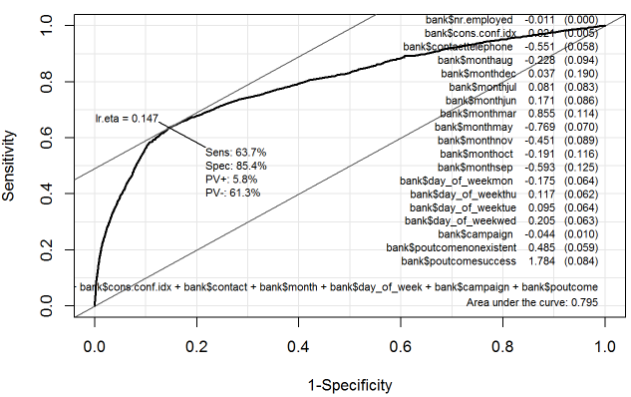

* Confusion metrics of the model:

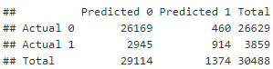

* The model is significant Chi sq= 4914.8, p<0.01. We have calculated the pseudo R Square statistics using Cox and Snell and Nagelkerke formula. The pseudo R square indicate that between 14.89% and 27.98% of the variability of responses to whether the customer opts for the term deposit or not.

### Predictors and their significance

* The model is created using 7 predictors mentioned below:
  1. Number of employees per quarter
  2. Consumer confidence index monthly rate
  3. Customer communication type
  4. Last contact month
  5. Last contact day of the week
  6. Number of contacts performed during this campaign and for this client
  7. Outcome of the previous marketing campaign
* Following are the co-efficient of the predictors along with their statistical significance:

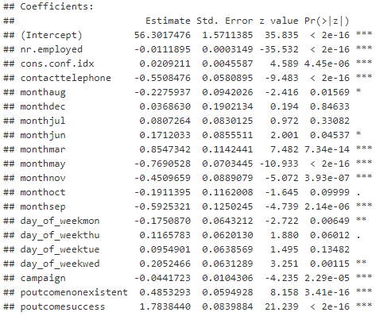

* Following are the odds ratio of all the predictors:

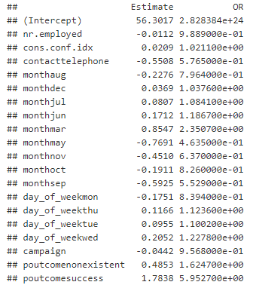

### Assess the model against assumptions

* The outcome variable can be ‘Yes’ or ‘no which means it is categorical and binomial in nature.
* The observations are individual calls made to different customers over period of time which means each observation is independent to one another.
* Examination for multicollinearity showed that the tolerance and variance influence factor measures were within acceptable levels (tolerance >0.4, VIF <2.5) as outlined in Tarling (2008).

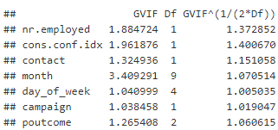 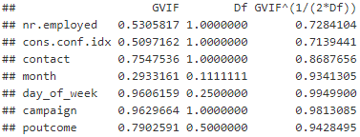

* The Hosmer Lemeshow goodness of fit statistic did not indicate any issues with the assumption of linearity between the independent variables and the log odds of the model (χ2(n=8)= = 32.412, p <0.001).

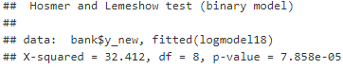

### Model Equation and Illustration

* The logistic regression equation is as follows:



* Where b0,b1b2…bn are the co-efficient. In this model, we found below coefficients

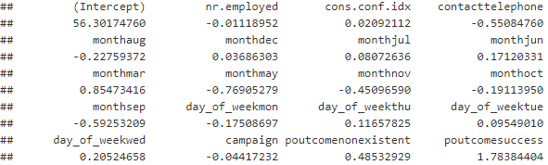

* The equation to calculate the probability for the below query will be:

Probability of bank term deposit sold when number of employees is at its minimum i.e. 4963.6, consumer price index is at its median i.e. -41.8 and customer contacted over cellular phone in the month of March, Wednesday, contacted once during this campaign and had a successful prior campaign.

56.30+(-0.011)* 4963.6+0.021*1+0.855*1+0.205*1+(-0.044)*1+1.784*1

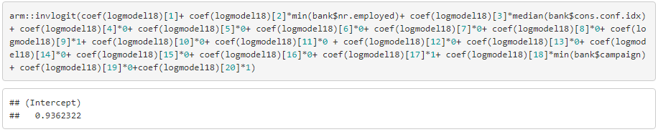

The probability is 94% of bank term deposit sold when number of employees is at its minimum i.e. 4963.6, consumer price index is at its median i.e. -41.8 and customer contacted over cellular phone in the month of March, Wednesday, contacted once during this campaign and had a successful prior campaign..

* Probability of bank term deposit sold when number of employees is at it’s minimum i.e 4963.6, consumer price index is at its median i.e. -41.8 and customer contacted over telephone in the month of May, Monday, contacted once during this campaign and had a failure prior campaign

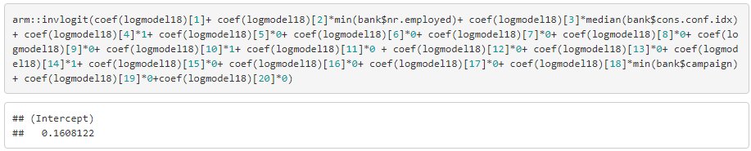

## Section 3.4 |Summary Comparison

Comparing model 1 and model 2

### Differences in fit and usefulness

|  |  |  |  |
| --- | --- | --- | --- |
| **Statistics** | **Model-1** | **Model-2** | **Result** |
| AIC | 18282 | 18285 | Model 1 better |
| AUC | 0.796 | 0.795 | Model 1 better |
| Cox and Snell R Square | 15.02% | 14.89% | Model 1 better |
| Nagelkerke R Square | 28.22% | 27.98% | Model 1 better |

### How models meet assumptions

**Model-1**

* Examination for multicollinearity showed that the tolerance and variance influence factor measures were within acceptable levels (tolerance >0.4, VIF <2.5) as outlined in Tarling (2008).

 

* The Hosmer Lemeshow goodness of fit statistic did not indicate any issues with the assumption of linearity between the independent variables and the log odds of the model (χ2(n=8)= =48.538, p <0.001).



**Model-2**

* Examination for multicollinearity showed that the tolerance and variance influence factor measures were within acceptable levels (tolerance >0.4, VIF <2.5) as outlined in Tarling (2008).

 

* The Hosmer Lemeshow goodness of fit statistic did not indicate any issues with the assumption of linearity between the independent variables and the log odds of the model (χ2(n=8)= = 32.412, p <0.001).



# Section 4 – Discussion/Conclusion

After doing logistic regression following are the conclusion drawn to the question

1. Do the social and economic indicators, client data and previous campaign attributes have an influence on a customer subscribing to a term deposit?

Following attributes have strong influence on a customer subscribing to a term deposit subscription:

* 1. Number of employees per quarter
  2. Customer Job
  3. Customer communication type
  4. Last contact month
  5. Last contact day of the week
  6. Number of contacts performed during this campaign and for this client
  7. Outcome of the previous marketing campaign

Additional research need to be conducted with a new sample data which is taken during non-recession period so that the representativeness will be much better. The calling agent attributes should be added to the research to find how the calling agent gender and experience influence the a customer subscribing to a term deposit.